- Generate Random numbers from a normal distribution, count occurrences.

Aim:
To generate random numbers from a normal distribution, count occurrences.
Procedure
Step 1: Open RStudio or R console on your computer.
Step 2: Set a random seed value to make the random results reproducible every time you run the program.
Step 3: Generate a set of random numbers from a normal distribution using the rnorm function.
Step 4: Round the generated random numbers to the nearest whole number to group similar values.
Step 5: Use the table function to count the frequency of each rounded value.
Step 6: Convert the frequency table into a data frame for easier viewing and structured display.
Step 7: Print the data frame to observe each rounded number along with its frequency count.
Code:
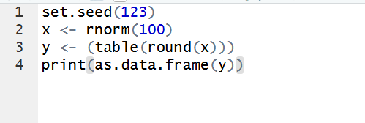
Output:
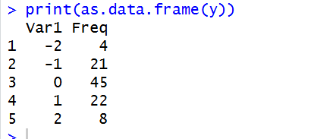
Result:
Hence the output is verified successfully.

